Contents

1 🔧What’s New 2

2 🚀 Fixed Defects 2

3 🚀 Fixed Issues 2

4 Accessibility fixes 3

5 ⭐ Improvements 3

6 🚀 Deployments 4

6.1 Infrastructure 4

6.2 CRM 5

6.2.1 CRM Pre Deployment Step 5

6.2.2 Deployment 5

6.2.3 CRM Post Deployment Verification 5

Verify workflows are activated from deployment guide (Refer 5.16 section) 5

6.3 CDN 5

6.4 Web Apps 6

6.5 Platform APIs 6

6.6 Mobile 6

7 💻 Reviewers 7

8 Appendix 8

8.1 Post Deployment Verification 8

8.2 Running Pipeline from Tags 8

Release Notes

# 🔧What’s New

New user stories delivered: **None**

# 🚀 Fixed Defects

The following bugs reported in SIT are addressed in the current interim build –

| **ID** | **Title** | **Severity** | **Priority** |
| --- | --- | --- | --- |
| [33616](https://dev.azure.com/TASMUCP/TASMU%20MSI/_workitems/edit/33616) | NF-Localization- Arabic- Session timeout popup is in English | 3 - Medium | 2 |
| [34146](https://dev.azure.com/TASMUCP/TASMU%20MSI/_workitems/edit/34146) | NF - the header is I sufficient to contain the plan title in Products price plan | 3 - Medium | 1 |
| [34675](https://dev.azure.com/TASMUCP/TASMU%20MSI/_workitems/edit/34675) | FN - My TASMU App - iOS - An error message displayed is not proper when user tries to login using LinkedIn | 3 - Medium | 1 |
| [35776](https://dev.azure.com/TASMUCP/TASMU%20MSI/_workitems/edit/35776) | FN-B2B Marketplace-User logs out of system as soon as it log in | 3 - Medium | 2 |
| [35873](https://dev.azure.com/TASMUCP/TASMU%20MSI/_workitems/edit/35873) | NF-App-Typo is observed for UI message on phone verification screen | 4 - Low | 2 |
| [35874](https://dev.azure.com/TASMUCP/TASMU%20MSI/_workitems/edit/35874) | FN-Portal-Notes for requests does not accept some special symbols where it should be a text field. | 3 - Medium | 2 |
| [35880](https://dev.azure.com/TASMUCP/TASMU%20MSI/_workitems/edit/35880) | FN - B2B - User is not able to search using Name in Orders page | 3 - Medium | 2 |

# 🚀 Fixed Issues

The following issues reported are addressed in the current build –

|  |  |  |  |
| --- | --- | --- | --- |
| ID | Type | Title | Priority |
| [35777](https://nam06.safelinks.protection.outlook.com/?url=https%3A%2F%2Fdev.azure.com%2FTASMUCP%2FTASMU%2520MSI%2F_workitems%2Fedit%2F35777&data=04%7C01%7CAbhishek.Ghosh%40microsoft.com%7C7bc8f43fb482464166b908d90fe6a3c1%7C72f988bf86f141af91ab2d7cd011db47%7C1%7C0%7C637558305533703254%7CUnknown%7CTWFpbGZsb3d8eyJWIjoiMC4wLjAwMDAiLCJQIjoiV2luMzIiLCJBTiI6Ik1haWwiLCJXVCI6Mn0%3D%7C1000&sdata=dnvozBDUFI5mtDzrwPVwJobfNqWNMaX%2Bc3fvOg6dtN4%3D&reserved=0) | Issue | FN - Portal - Text values to be changed | 1 |
| [35781](https://nam06.safelinks.protection.outlook.com/?url=https%3A%2F%2Fdev.azure.com%2FTASMUCP%2FTASMU%2520MSI%2F_workitems%2Fedit%2F35781&data=04%7C01%7CAbhishek.Ghosh%40microsoft.com%7C7bc8f43fb482464166b908d90fe6a3c1%7C72f988bf86f141af91ab2d7cd011db47%7C1%7C0%7C637558305533713210%7CUnknown%7CTWFpbGZsb3d8eyJWIjoiMC4wLjAwMDAiLCJQIjoiV2luMzIiLCJBTiI6Ik1haWwiLCJXVCI6Mn0%3D%7C1000&sdata=dta44fVu5lQ%2FkRg8meNFGcTxegJCpnzTXcLZ%2BcLTE7c%3D&reserved=0) | Issue | Organization verification documents list | 1 |

# Accessibility fixes

The following issues related to accessibility have been addressed in this build –

|  |  |
| --- | --- |
| **ID** | **Title** |
| [35004](https://dev.azure.com/TASMUCP/TASMU%20MSI/_workitems/edit/35004) | NF-Accessibility-IOS iPhone Application-Home Screen |
| [35007](https://dev.azure.com/TASMUCP/TASMU%20MSI/_workitems/edit/35007) | NF-Accessibility-IOS iPhone Application-Home Screen-Form: Complaint / Feedback |
| [35755](https://dev.azure.com/TASMUCP/TASMU%20MSI/_workitems/edit/35755) | NF-Accessibility-IOS iPhone Application-Screen 2: Registration |
| [35756](https://dev.azure.com/TASMUCP/TASMU%20MSI/_workitems/edit/35756) | NF-Accessibility-IOS iPhone Application-Smart Services |

# ⭐ Improvements

1. Email template design updates for CMS related emails
2. Scale Settings update for AKS, Application Gateways, APIM, Search Service, Cognitive App Service Plan and Cosmos Containers.

# 🚀 Deployments

## Infrastructure

Pull Request – <https://dev.azure.com/TASMUCP/TASMU%20MSI/_git/infra/pullrequest/6776>

Steps:

1. Parameter file updates
   1. logic-<sub>-apps-intgbaprl-<env>-we-01
   2. logic-<sub>-apps-intrsl-<env>-we-01
   3. logic-<sub>-apps-intaprv1-<env>-we-01

Please Refer PR : [6783](https://dev.azure.com/TASMUCP/TASMU%20Central%20Platform/_git/infra/pullrequest/6783) for the changes required to be incorporated.

1. Manual Step on cosmos-<sub>-apps-str-<env>-we-01
   1. For all the 5 containers:
      1. botstate
      2. feedback
      3. rating
      4. history
      5. transactionhistory
   2. Update the Scale & Settings to **Autoscale** and save.
   3. Change the Max RU/s to **6000** and save.

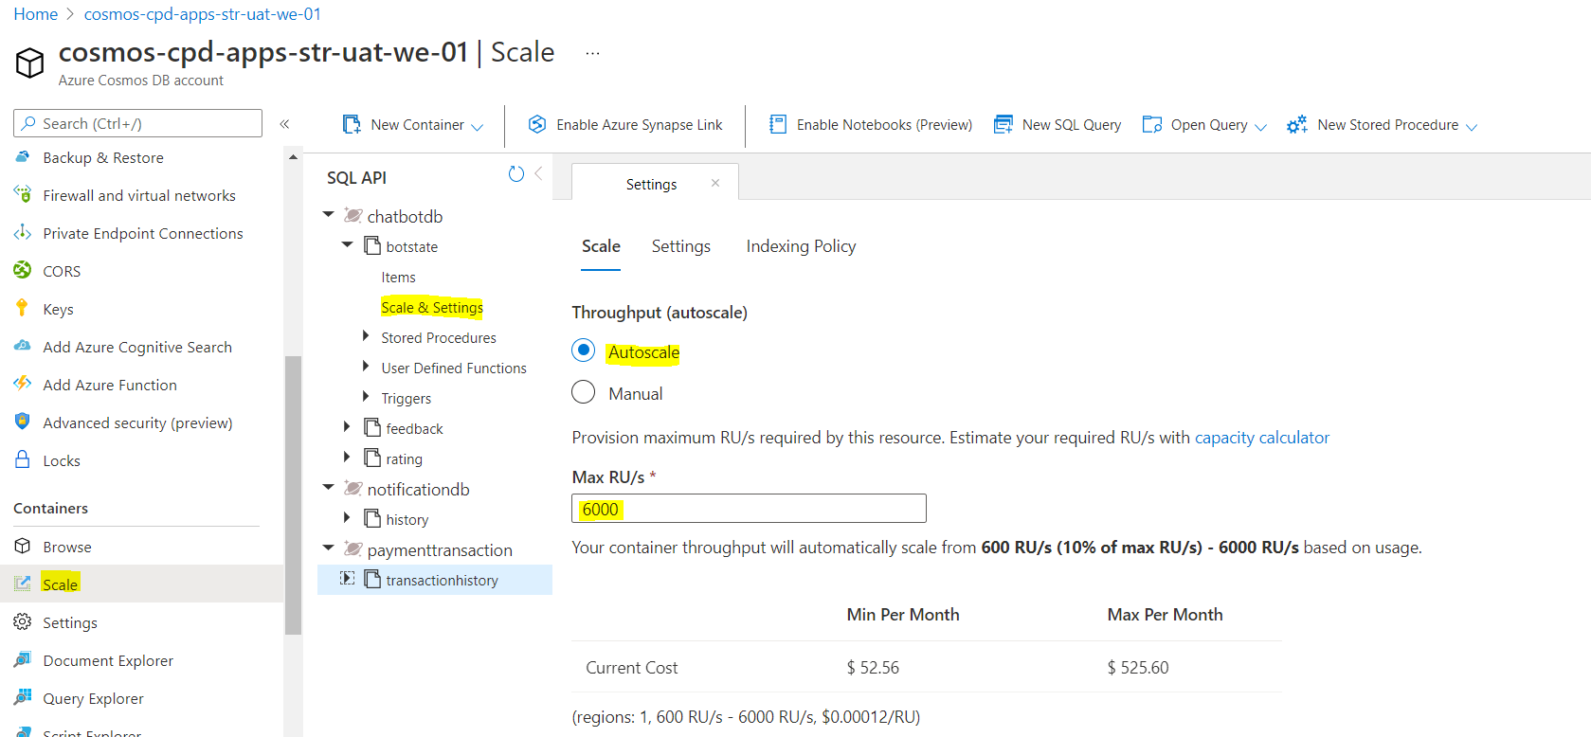

1. Deploy
   1. rg-<sub>-apps-aks-<env>-we-01 (Scale Updates)
   2. rg-<sub>-apps-waf-<env>-we-01 (Scale Updates)
   3. rg-<sub>-shrd-<env>-we-01 (Scale Updates)
   4. rg-<sub>-apps-cog-<env>-we-01 (Scale Updates)
   5. rg-<sub>-apps-int-<env>-we-01
   6. CD-AppConfigurations-Master-Release
2. Apply the updates on prd as well.
3. It is noticed that prd does not have AppServicePlanScale - scale-<sub>-apps-cog-<env>-we-01 (refer pre to update prd)

## CRM

### CRM Pre Deployment Step

Manually import processes solution before deployment to higher environments.  
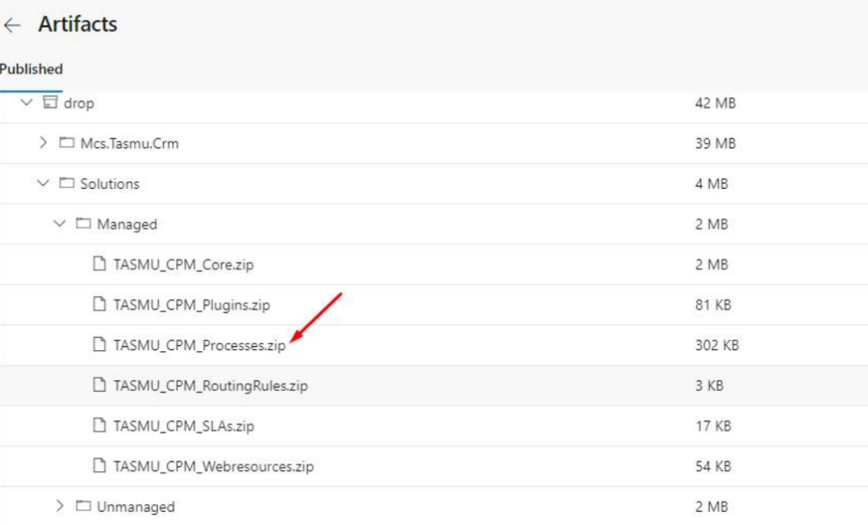

### Deployment

|  |  |
| --- | --- |
| **Build Id** | **Pipeline Name** |
| 42313 | [CD-CrmPlatform-Release](https://dev.azure.com/TASMUCP/TASMU%20Central%20Platform/_build/results?buildId=42402&view=results) |

### CRM Post Deployment Verification

### [Verify workflows are activated from deployment guide](https://dev.azure.com/TASMUCP/TASMU%20Central%20Platform/_wiki/wikis/TASMU-Central-Platform.wiki/137/Dynamics-365-Deployment-Guide) (Refer 5.16 section)

## CDN

|  |  |
| --- | --- |
| **Tag** | **Pipeline Name** |
| SIT_CDN_11May2021 | [CD-CDNContainer-Prd-Release](https://dev.azure.com/TASMUCP/TASMU%20Central%20Platform/_build?definitionId=1019) |

## Web Apps

|  |  |
| --- | --- |
| **Tag** | **Pipeline Name** |
| SIT_Web_11May2021 | [CD-WebApps-Prd-Release](https://dev.azure.com/TASMUCP/TASMU%20Central%20Platform/_build?definitionId=1020) |

## Platform APIs

|  |  |
| --- | --- |
| **Tag** | **Pipeline Name** |
| SIT_API_11May2021 | [CD-PlatformAPIs-Prd-Release](https://dev.azure.com/TASMUCP/TASMU%20Central%20Platform/_build/results?buildId=42372&view=results) |

## Mobile

|  |  |  |
| --- | --- | --- |
| **Platform** | **Build Id** | **Pipeline Link** |
| Android | 42390 | <https://dev.azure.com/TASMUCP/TASMU%20Central%20Platform/_build/results?buildId=42390&view=results> |
| iOS | 42391 | <https://dev.azure.com/TASMUCP/TASMU%20Central%20Platform/_build/results?buildId=42391&view=results> |

# 💻 Reviewers

|  |  |
| --- | --- |
| Prepared By | Manvir Kaur, Sumit Gupta |
| Company name | Microsoft |
| Reviewed by | Ravi Sankar Pillutla, Anil Erkek, Abhishek Ghosh, Subhajit Chatterjee, Gareeb Navas T M, Mecit Atmaca |
| Approved by | Ashwani Sharma |

# Appendix

## Post Deployment Verification

1. Function Apps Running
2. <https://func-cpp-apps-ckan-pre-we-01.azurewebsites.net/>
3. <https://func-cpp-apps-qnasync-pre-we-01.azurewebsites.net/>
4. <https://func-cpp-apps-luistra-pre-we-01.azurewebsites.net/>
5. <https://func-cpp-apps-intbpa-pre-we-01.azurewebsites.net/>
6. <https://func-cpp-apps-intntf-pre-we-01.azurewebsites.net/>
7. <https://func-cpp-apps-pt-pre-we-01.azurewebsites.net/>
8. Marketplace Portal - <https://marketplace.pre.sqcp.qa/en/>
9. Bot – Chat with bot on marketplace
10. My Tasmu Portal - <https://mytasmu.pre.sqcp.qa/en/>
11. Account Portal - <https://account.pre.sqcp.qa/en/>
12. Admin Portal Portal - [https://cpadmin.pre.sqcp.qa](https://cpadmin.pre.sqcp.qa/)  (Login screen should come)
13. API Config access - <https://api.pre.sqcp.qa/config/api/feature>
14. Open Data Portal - <https://opendata.pre.sqcp.qa/>

## Running Pipeline from Tags

